Project Enhancements

# Standard Project without Enhancements

## Quick Create Form

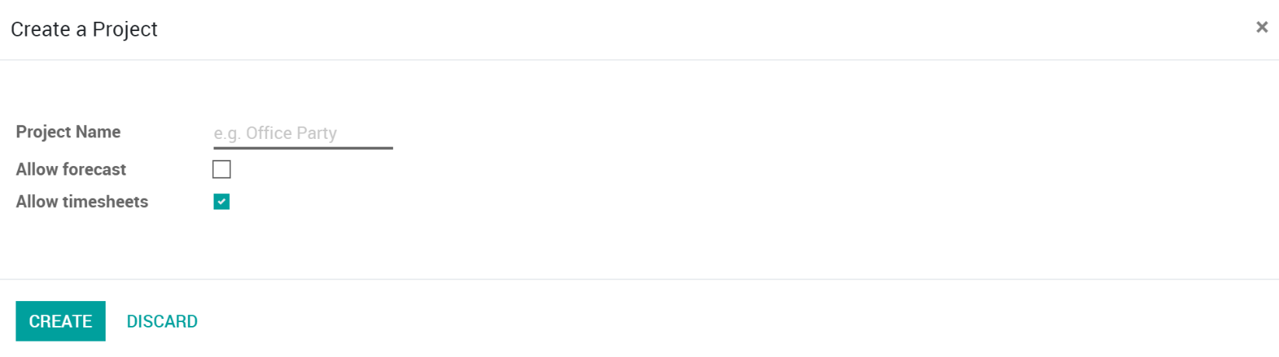

## Project Form

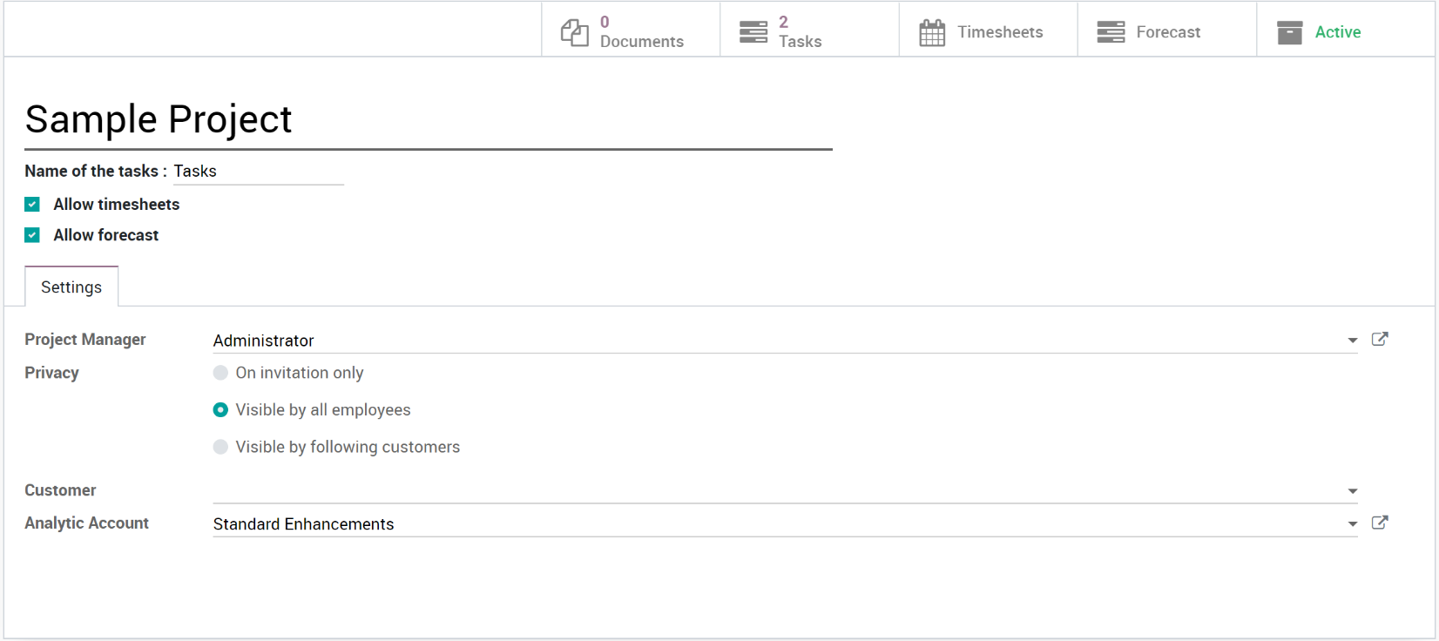

# Project Enhancement

## Quick Create Form

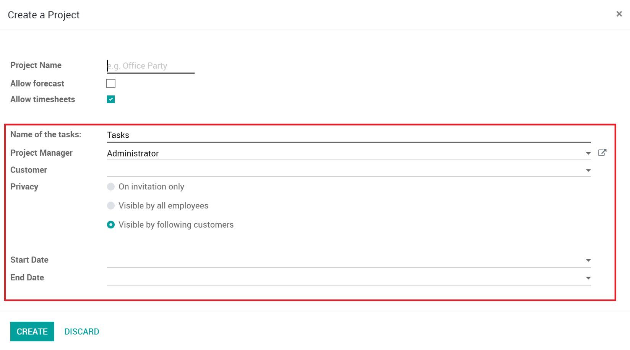

## Project Form

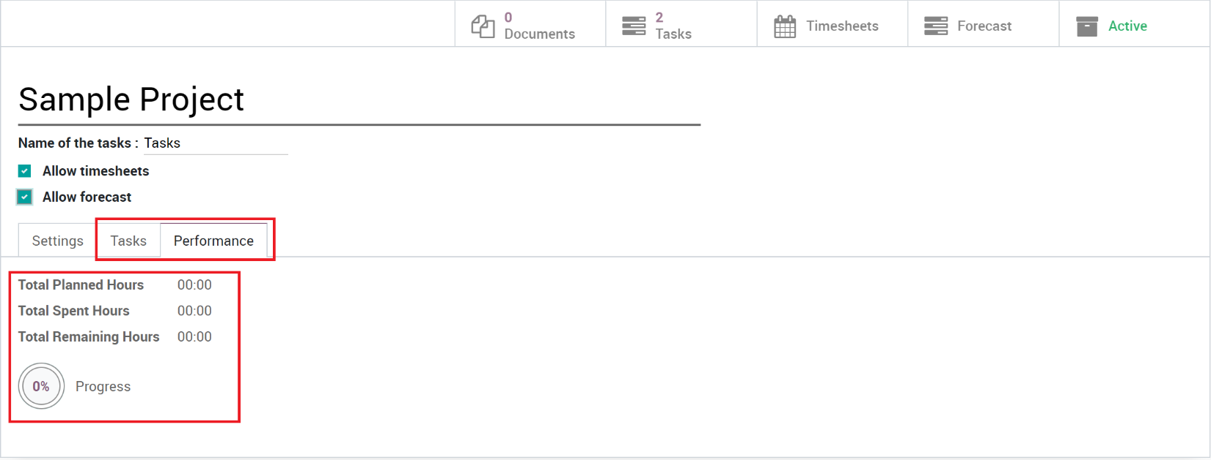

# Project Types

## Quick Create Form

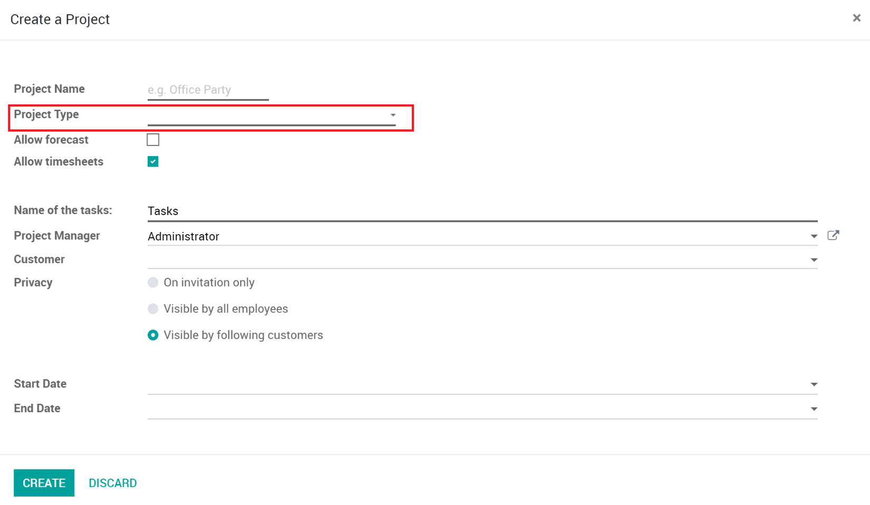

## Project Form

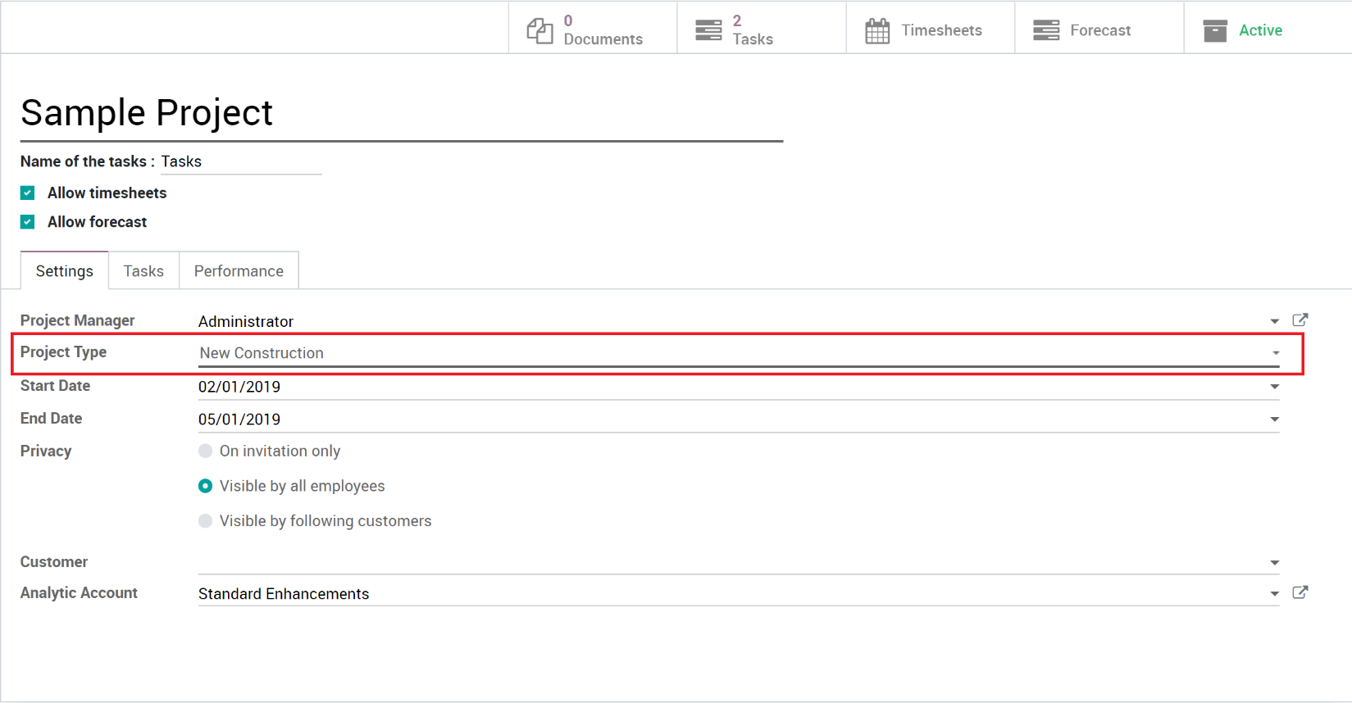

# Project Statuses

## Quick Create Form

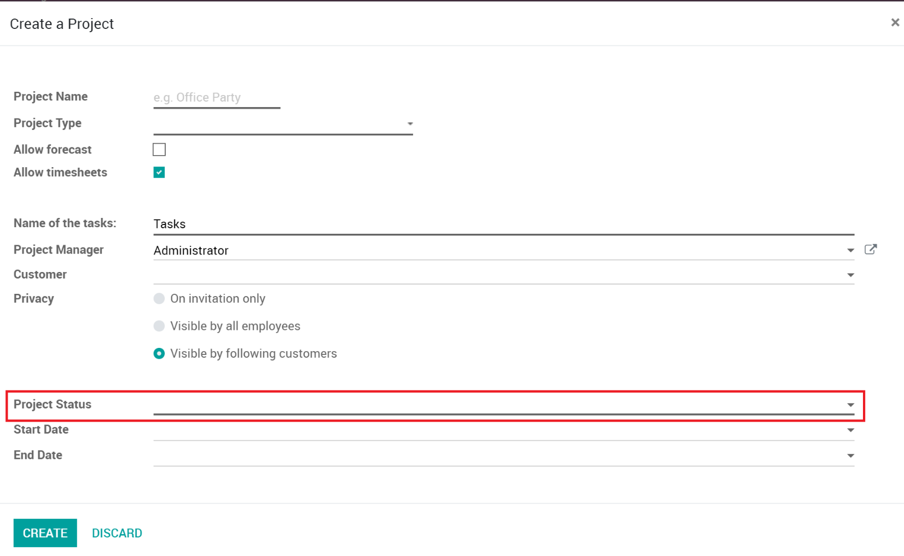

## Project Form

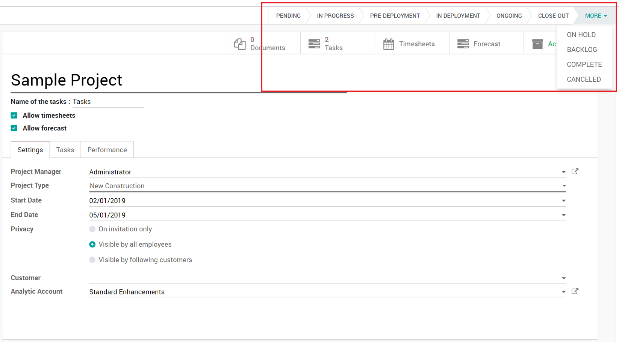

# Project Department

## Quick Create Form

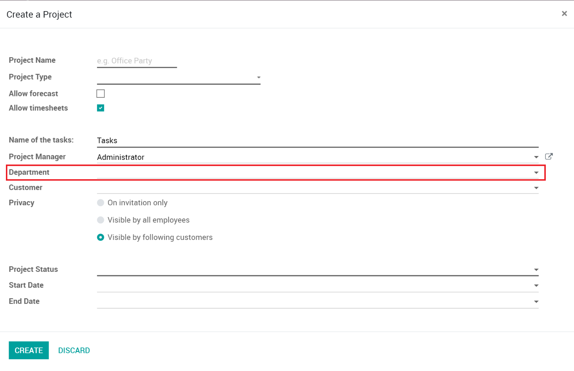

## Project Form

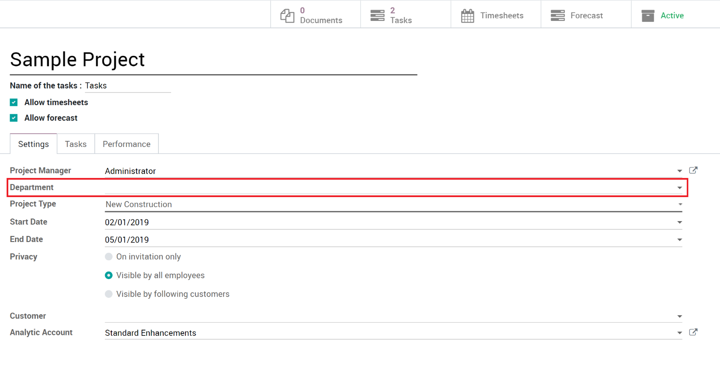

# Project Template

## Quick Create Form

No Changes

## Project Form

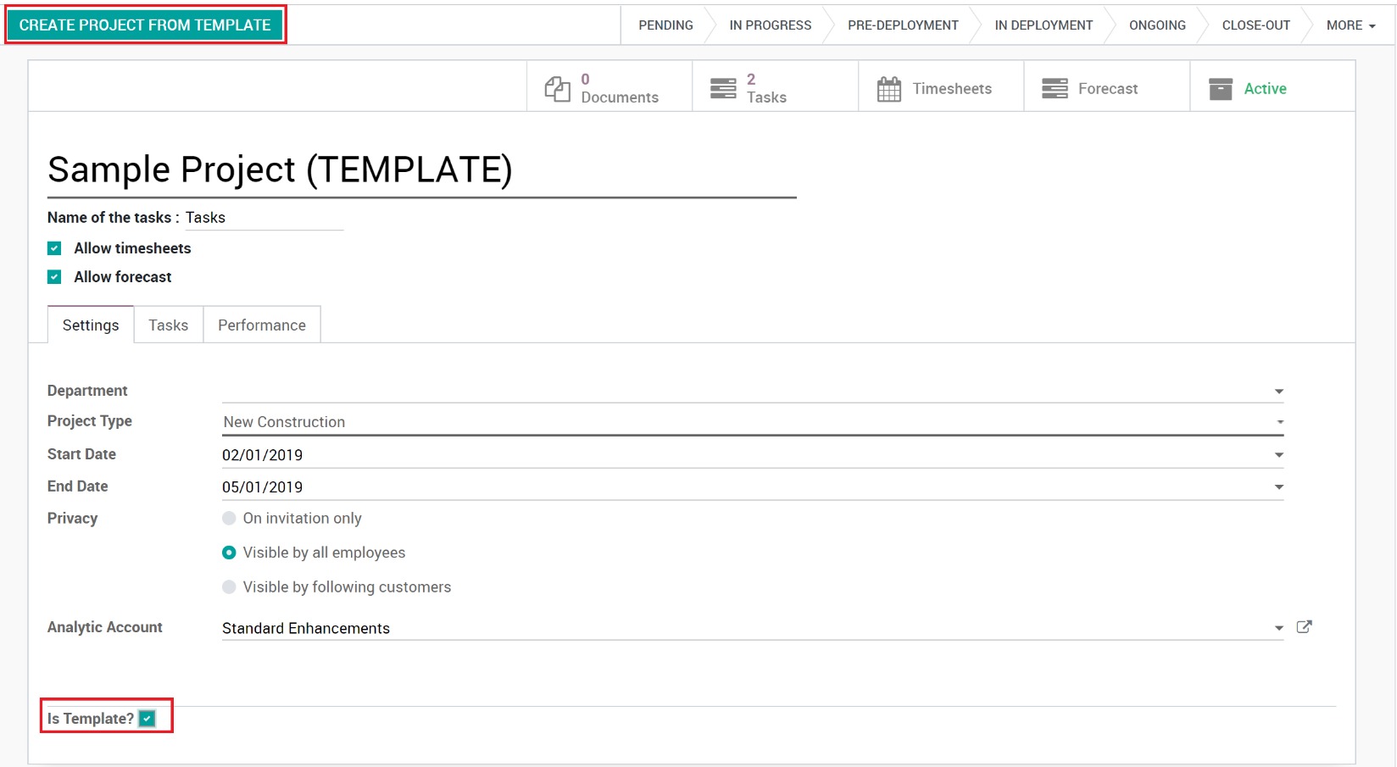

# Project Milestones

## Quick Create Form

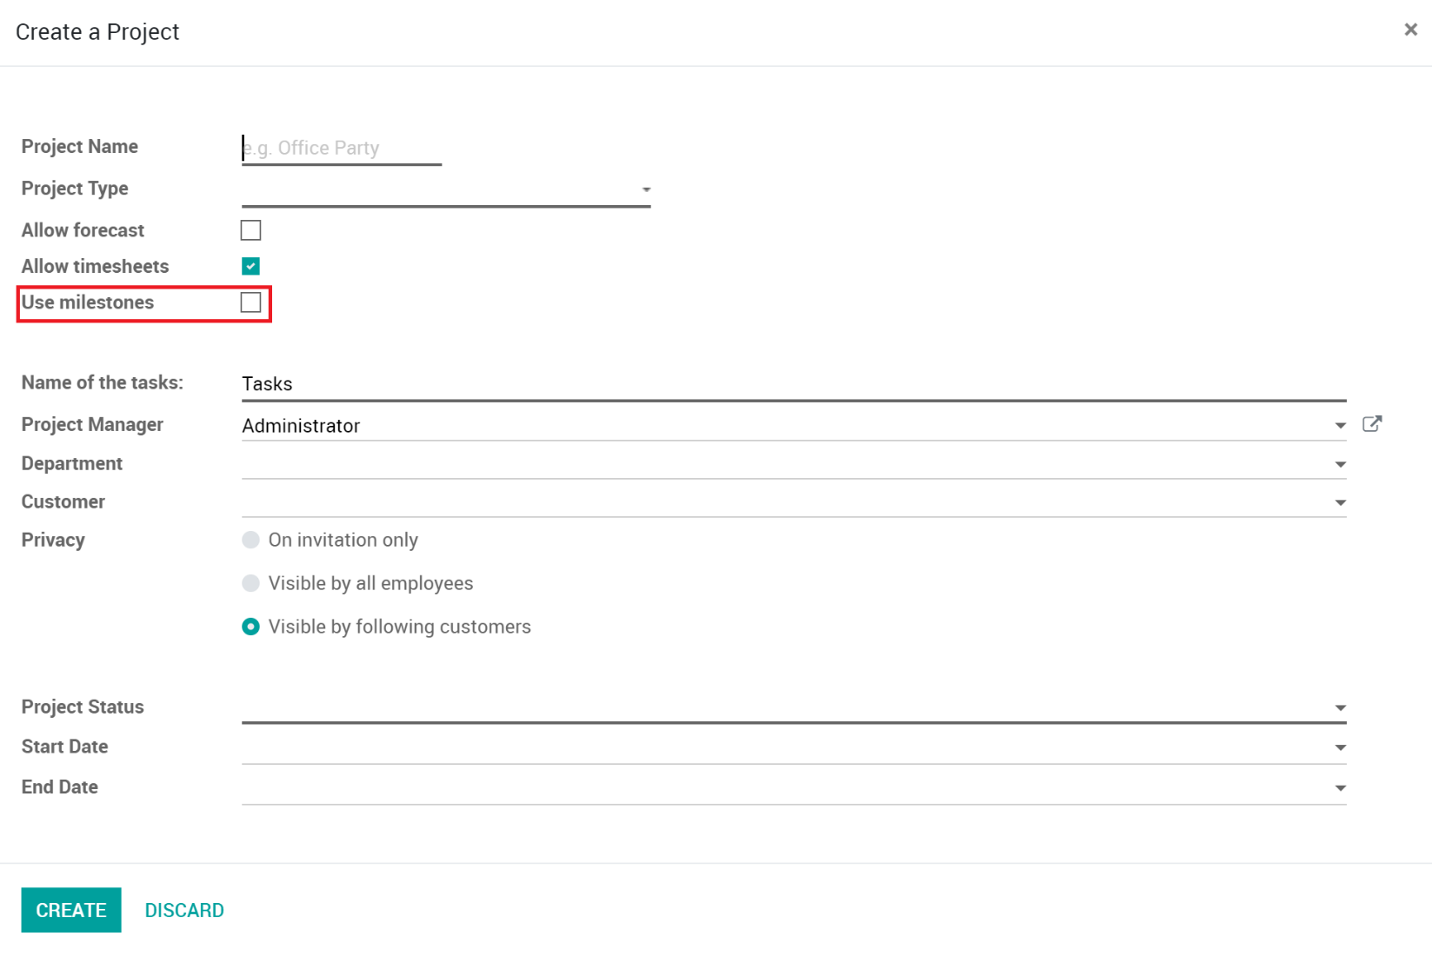

## Project Form

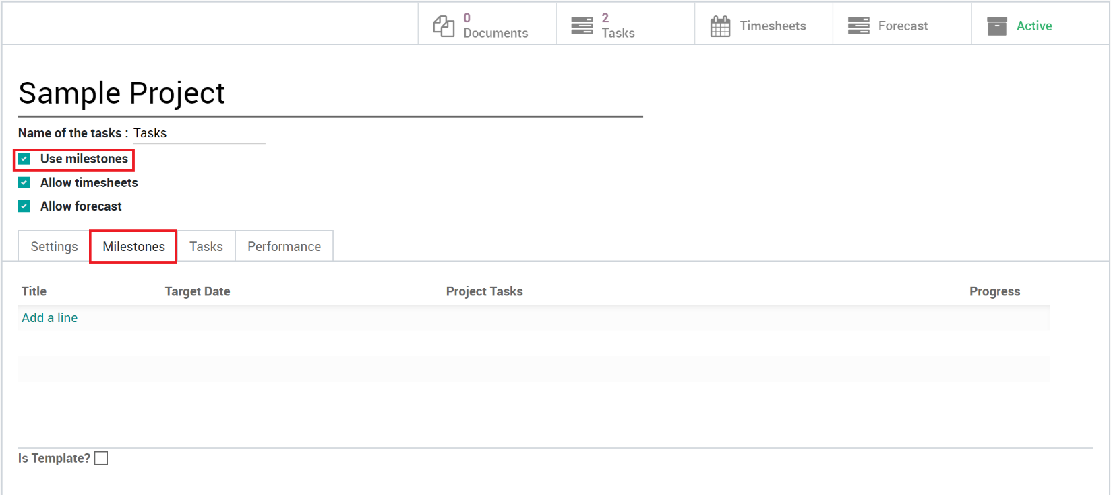

# Project Task Date Shifting

## Quick Create Form

No Change

## Project Form

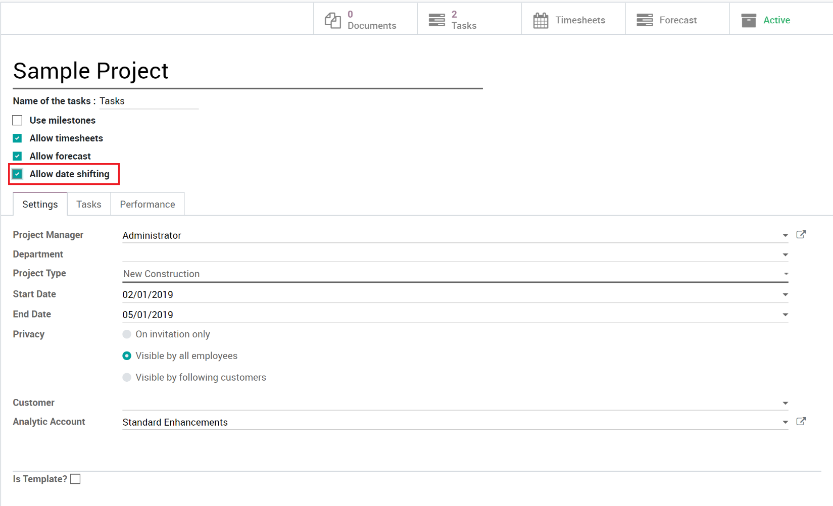

# Project Auto Forecast

## Quick Create Form

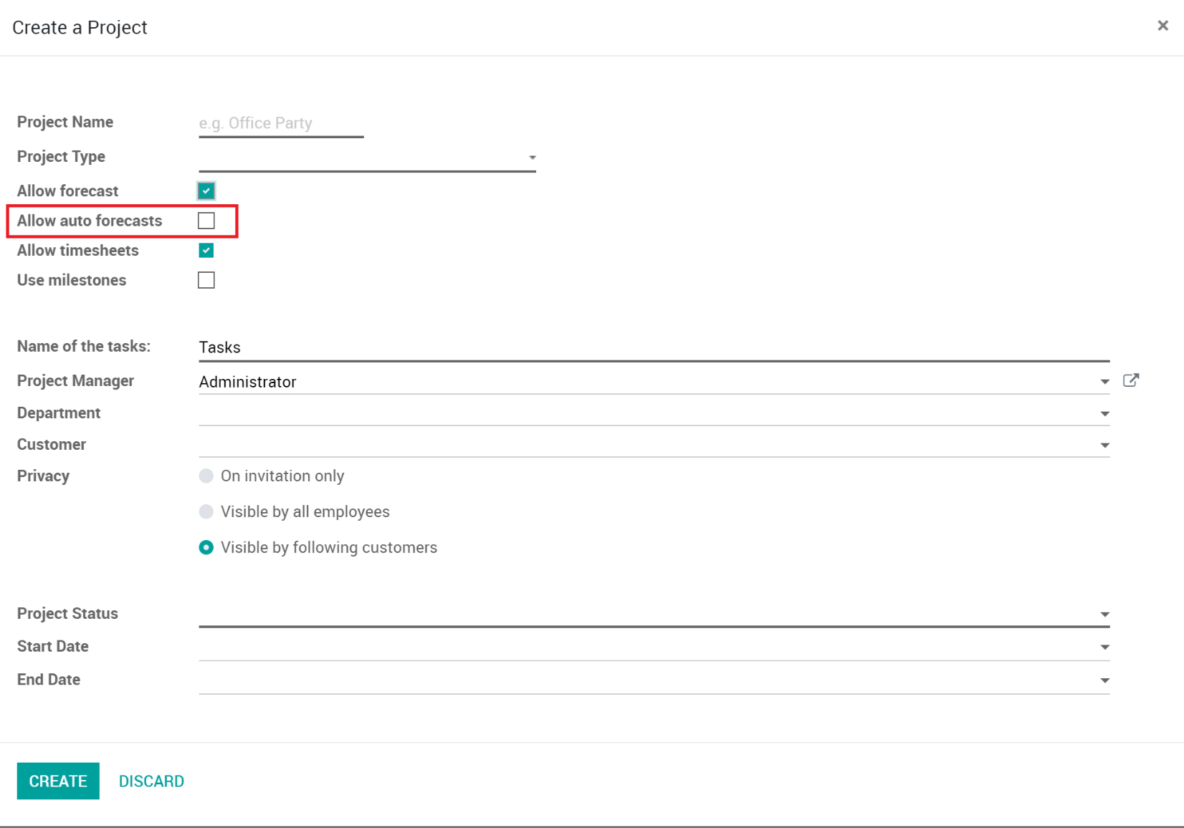

## Project Form

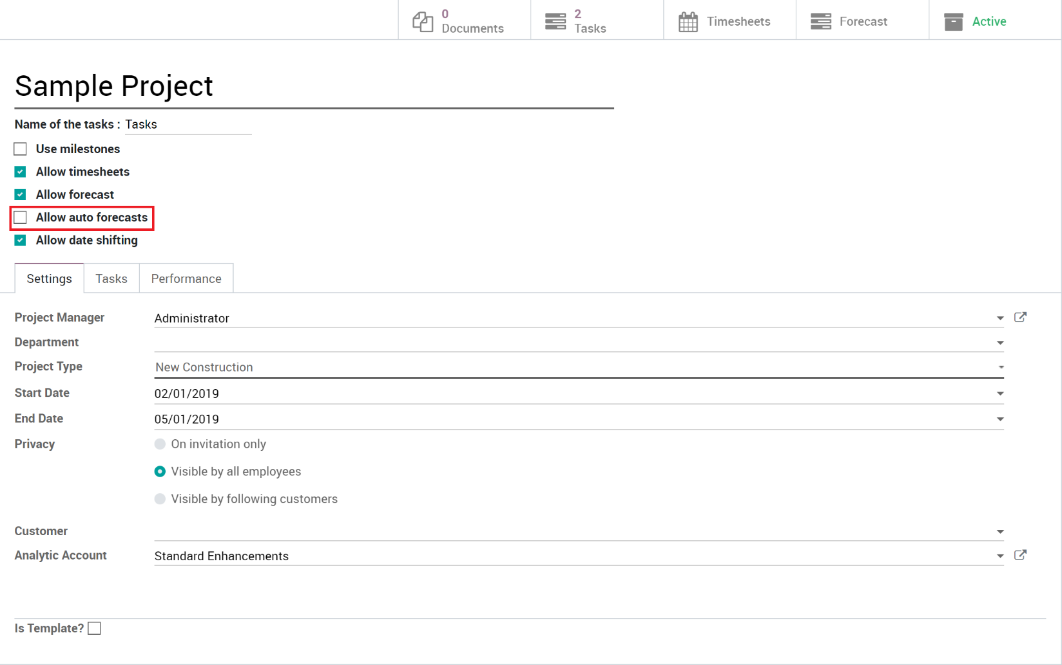

# Project Scrum

## Quick Create Form

## Project Form